Synopsis

Prediction of Congestion in Campus Wi-Fi Networks using Machine Learning

Project Id:
Problem Id:

Student Name : Simran Kundiyal
University Roll number : 2519528
Section : X

Student Name : Yash Negi
University Roll number : 2519577
Section : X

Index

- Problem Description 3

- Architecture 4

- Models model 5

- Evaluation metrics used 6

- Preliminary Results and Visualization 7

- References 8

- Problem Description:
With the increasing dependence on campus Wi-Fi networks for academic, administrative, and personal use, network congestion has become a critical issue affecting performance, user experience, and service reliability. Congestion occurs when network demand exceeds available capacity, leading to high latency, packet loss, and reduced bandwidth efficiency. Identifying and predicting such congestion in advance is essential for effective network management.
This project aims to design and develop an end-to-end machine learning classification system that analyzes network performance data—such as number of connected devices, latency, packet loss rate, bandwidth usage, and access point load—to predict congestion levels. The system involves data preprocessing, exploratory data analysis to understand patterns and anomalies, feature selection for improving model accuracy, and building predictive models.
In real life, this solution helps network administrators proactively manage traffic, optimize resource allocation, and ensure smooth connectivity across campus environments. It supports better decision-making, reduces downtime, and enhances overall user satisfaction by maintaining efficient and reliable Wi-Fi services.

- Architecture
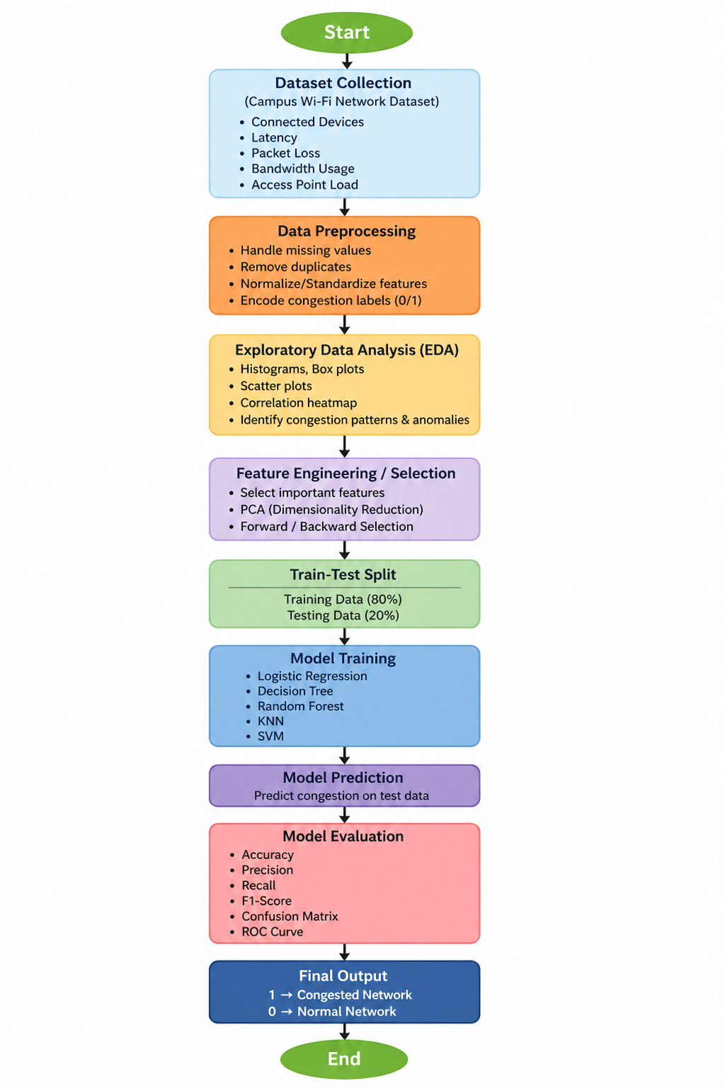
Fig 1: Showing architecture flowchart

- Models Used(Applied/ Planned) Give a brief introduction of the models used

1. Logistic Regression
A statistical classification algorithm that predicts the probability of Wi-Fi congestion using a sigmoid function. It is simple, fast, and effective for baseline performance in binary classification problems.

2. Random Forest Classifier
An ensemble learning technique that builds multiple decision trees and combines their outputs for better accuracy. It handles complex relationships between features like latency, packet loss, and bandwidth, and reduces overfitting.

3. Support Vector Machine (SVM)
A powerful algorithm that finds the optimal hyperplane to separate congested and non-congested classes. It performs well in high-dimensional data and can model non-linear boundaries using kernel functions.

- Evaluation metrics used

1. Accuracy
Measures the overall performance of the model by calculating the percentage of correctly predicted instances out of total instances.

2. Confusion Matrix
A table used to evaluate model performance by showing:
- True Positive (TP)
- True Negative (TN)
- False Positive (FP)
- False Negative (FN)
It helps in understanding how well the model is classifying congested and non-congested cases.

3. Heatmap (Confusion Matrix Visualization)
A visual representation of the confusion matrix using colors. It makes it easier to interpret model performance and identify prediction errors.

4. Model-wise Heatmaps
Separate heatmaps are generated for each model:
- Logistic Regression
- Random Forest Classifier
- Support Vector Machine (SVM)
These heatmaps allow comparison of model performance and help in selecting the best model for Wi-Fi congestion prediction.

- Preliminary Results and Visualizations

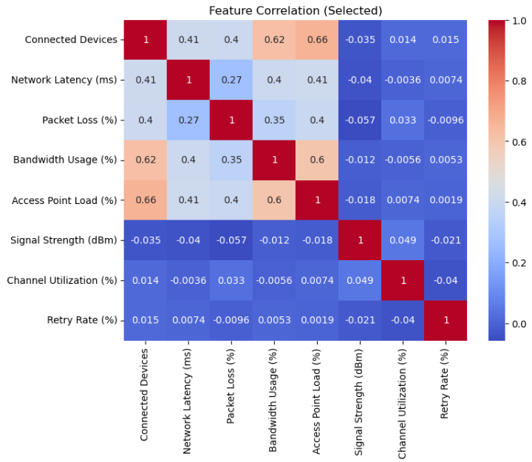
Fig 2: Figure Showing Heatmap of Feature Correlation

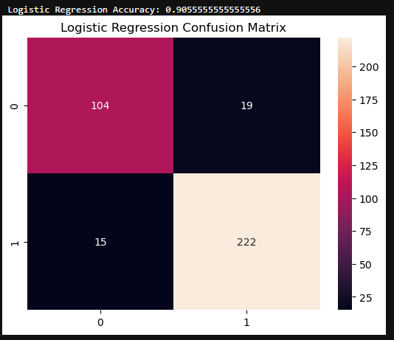
Fig 3: Figure Showing Logistic Regression Confusion Matrix and Accuracy
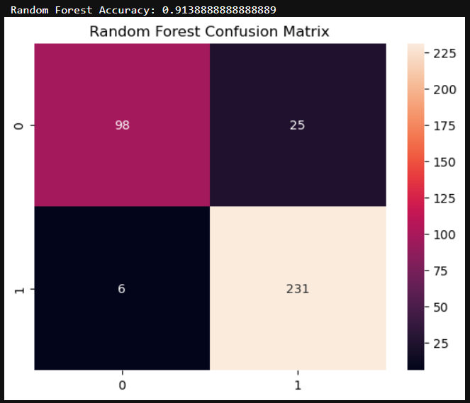
Fig 4: Figure Showing Random Forest Confusion Matrix and Accuracy
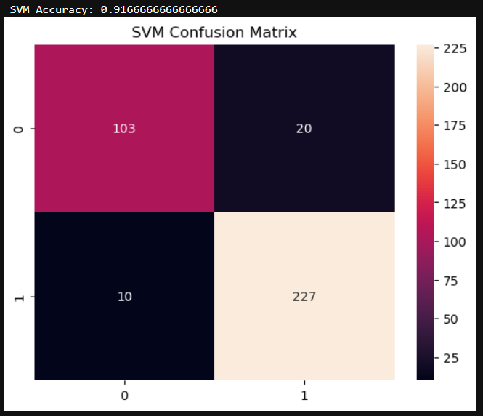
Fig 5: Figure Showing SVM Confusion Matrix and Accuracy

- References

1. Hands-On Machine Learning with Scikit-Learn, Keras & TensorFlow

By - Aurélien Géron (Book)
A comprehensive book covering the complete ML pipeline including preprocessing, EDA, feature selection, model building, and evaluation. Useful for understanding end-to-end system design.

2. Scikit-learn Official Documentation (ML Models & Preprocessing)
https://scikit-learn.org/stable/
Covers data preprocessing, feature selection methods (PCA), and classification algorithms like Logistic Regression, SVM, KNN, etc.

3. Kaggle Learn (Practical ML & EDA Tutorials)
https://www.kaggle.com/learn
Offers hands-on tutorials on data preprocessing, EDA, feature engineering, and machine learning workflows.

4. Official Seaborn Heatmap Documentation
https://seaborn.pydata.org/generated/seaborn.heatmap.html
Explains how to use heatmaps in seaborn library

